**DESIGN DIAGRAM :**

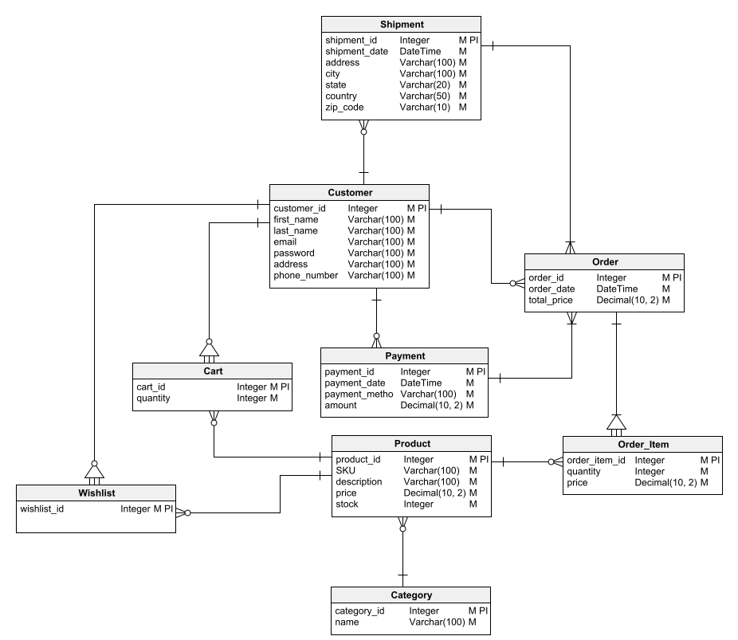

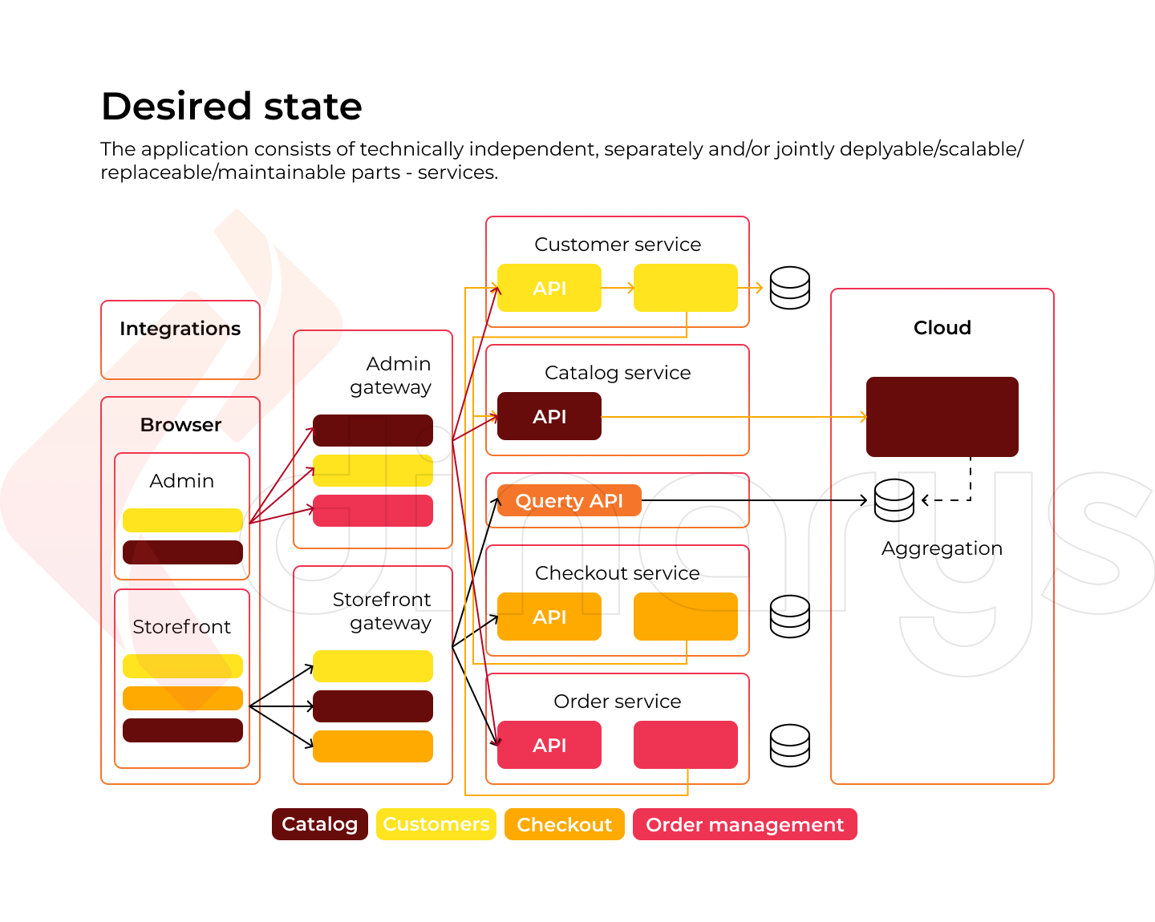

**DATASETS AND PROPERTIES :**

Creating an E-Commerce website requires a variety of datasets and properties to effectively manage and operate the online store. Here are some essential datasets and their properties:

**Product Data:**

* **Product ID:** A unique identifier for each product.
* **Product Name:** The name or title of the product.
* **Description:** Detailed information about the product.
* **Price:** The price of the product.
* **Category:** The category or type of the product.
* **Stock Availability:** Quantity of the product in stock.
* **Images:** High-quality images of the product.
* **Reviews and Ratings:** Customer reviews and product ratings.

**Customer Data:**

* **Customer ID:** A unique identifier for each customer.
* **Name:** Customer's name.
* **Email:** Customer's email address.
* **Shipping Address:** Address for product delivery.
* **Billing Information:** Payment details (e.g., credit card information).
* **Order History:** Records of past orders made by the customer.
* **Wishlist:** Products saved for future purchase.

**Order Data:**

* **Order ID:** A unique identifier for each order.
* **Customer ID:** ID of the customer who placed the order.
* **Order Date:** Date and time the order was placed.
* **Shipping Address:** Address where the order will be delivered.
* **Payment Information:** Payment method, transaction ID, and total amount.
* **Order Status:** Current status of the order (e.g., processing, shipped, delivered).
* **Order Items:** List of products included in the order.

**Inventory Data:**

* **Inventory ID:** Unique identifier for each inventory item.
* **Product ID:** ID of the product associated with the inventory item.
* **Quantity:** The number of items in stock.
* **Location:** Where the inventory item is stored (e.g., warehouse, store).

**User Data:**

* **Admin/User ID:** Unique identifier for website administrators and users.
* **Username:** User's login username.
* **Password:** Securely stored user password.
* **Roles:** User roles (e.g., admin, customer, vendor).
* **Permissions:** Access control rights for different parts of the website.

**Analytics Data:**

* **Website Traffic:** Information about website visitors, including IP addresses, user agents, and referral sources.
* **Sales Data:** Sales figures, revenue, and profit margins.
* **Conversion Rates:** Percentage of visitors who make a purchase.
* **Abandoned Carts:** Data on customers who added items to their cart but did not complete the purchase.
* **Customer Behavior:** Data on browsing patterns and click-through rates.

These datasets and their properties are essential for the efficient functioning of an E-Commerce website, enabling product management, customer engagement, order processing, and data analysis for continuous improvement. Proper data management and security measures are crucial to protect customer and business information.

**PREPROCESSING :**

Preprocessing in the context of an E-Commerce website refers to the various steps and techniques used to prepare and manage data, content, and user interactions to ensure a seamless and efficient online shopping experience. Effective preprocessing can help improve website performance, user engagement, and ultimately drive sales. Here are some key areas where preprocessing plays a crucial role in E-Commerce websites:

**Data Collection and Integration:**

* Gather and integrate product data from various sources, including suppliers, manufacturers, and internal databases.
* Ensure data consistency, accuracy, and completeness.

**Data Cleaning:**

* Remove duplicate product listings and outdated information.
* Correct errors, such as misspellings and inconsistent product attributes.

**Data Normalization:**

* Ensure that product attributes (e.g., size, color, price) are standardized and follow a consistent format.

**Image Processing:**

* Optimize product images for fast loading and a visually appealing user experience.
* Generate multiple image sizes for responsive design.
* Use image compression techniques to reduce file size without sacrificing quality.

**Content Management:**

* Create and manage product descriptions, titles, and metadata for search engine optimization (SEO).
* Implement content policies to maintain a consistent and professional tone across product listings.

**User Data Preprocessing:**

* Handle user data securely and in compliance with data protection regulations (e.g., GDPR, CCPA).
* Implement user data validation and sanitization to prevent security vulnerabilities (e.g., SQL injection, cross-site scripting).

**Search and Navigation:**

* Implement search functionality with preprocessing techniques like indexing and ranking to deliver relevant search results quickly.
* Create filters and facets to help users narrow down product choices.

**Recommendation Systems:**

* Analyze user behavior and preferences to provide personalized product recommendations.
* Collaborative filtering, content-based filtering, and machine learning algorithms can be used for recommendation preprocessing.

**Inventory Management:**

* Keep track of product stock levels and update product availability in real-time.
* Implement backorder and pre-order processing if applicable.

Effective preprocessing in E-Commerce websites can significantly impact the user experience, conversion rates, and overall success of the online store. It requires a combination of data management, technical optimization, and user-centric design considerations.

**FEATURE EXTRACTING :**

Feature extraction in the context of an E-Commerce website refers to the process of identifying and selecting important attributes or characteristics from the raw data and content to create meaningful, actionable features. These features can be used for various purposes, including improving user experience, personalization, recommendation systems, and analytics. Here are some common feature extraction techniques and examples for E-Commerce websites:

**Product Features:**

* **Product Attributes:** Extract relevant product attributes such as title, description, price, brand, category, size, color, and availability.
* **Images:** Extract features from product images, such as image captions, dominant colors, or image similarity scores for recommendation.

**User Features:**

* **User Behavior:** Capture user interactions, including clicks, views, searches, and purchases, to create user profiles and preferences.
* **Demographics:** Extract user demographics like age, gender, location, and shopping history to personalize recommendations and marketing.

**Text Features:**

* NLP Techniques: Use natural language processing (NLP) to extract sentiment analysis, keywords, and topic modeling from product reviews, customer feedback, and user-generated content.
* Search Queries: Analyze search queries to identify popular keywords and trending products.

**Interaction Features:**

* **Time-Based Features:** Extract time-related features like session duration, time of day, day of the week, and seasonality to optimize marketing campaigns and promotions.
* **Clickstream Analysis:** Create features from the user's clickstream data to understand user paths and behavior within the website.

**Recommendation Features:**

* **Collaborative Filtering:** Extract user-item interaction data to build collaborative filtering features, such as user-item matrices or similarity scores.
* **Content-Based Features:** Use product content and user profiles to create content-based features for personalized recommendations.

**Feedback and Reviews:**

* **Product Ratings:** Calculate average product ratings and sentiment scores from user reviews.
* **Review Counts:** Use the number of reviews as a feature to gauge product popularity and trustworthiness.

**Payment and Transaction Features:**

* **Payment Methods:** Extract data on preferred payment methods and create features for payment option recommendations.
* **Transaction History:** Analyze user transaction history to identify spending patterns and create relevant features.

Effective feature extraction in E-Commerce can enable better product recommendations, personalization, marketing strategies, and user experience enhancements. These features play a crucial role in driving customer engagement, increasing conversions, and ultimately improving the overall performance of an E-Commerce website.